**Hardware Design**

1. **Schematic Design**

In this project, we have designed a schematic for the Flyback Converter hardware, by considering detailed simulation with LT8316 and DC2718A Demo Board Schematic, which is a 16V-600V input, 12V-3A output Flyback Converter demo board with LT8316. As a consequence of having a capable controller and tertiary winding transformer, we do not need any digital isolator (i.e. optocoupler) between two isolation boundaries. So, we have concluded our schematic with the controller, transformer, connectors, and some discrete components (discussed in the component selection part) such as resistors, capacitors, diodes. We have not needed any extra ICs. Compared with Simulation Report, some of the components have changed in schematic design and they are discussed in Component Selection and Controller Part.

In the component selection part, we have discussed feedback resistors, UVLO resistors, and sense resistors for the controller. There are some additional recommended components, that we placed in our schematic design. We can have a short discussion about these components:

**IntVcc Pin:** This pin is to maintain the internal supply voltage that is taken from the Bias pin. In order to do that, the datasheet recommends a minimum 2.2uF capacitor, in the schematic we have placed a 4.7uF capacitor.

**Bias Pin:** This pin takes the internal supply voltage from tertiary windings, so the datasheet recommends a bypass capacitor to the ground. We have placed a 4.7uF ceramic capacitor, again.

**Smode Pin:** This pin is used for stand-by operation. In order to avoid that we have connected it to the ground.

**Vc Pin:** This pin is the Loop Compensation pin, which determines the switching frequency from the feedback voltage. The datasheet recommends an R-C network to stabilize the regulation generally with a 20kohm resistor and 220nF capacitor. Normally decreasing R-value and increasing C value causes transient problems and increasing R-value and decreasing C value causes high-frequency problems. However, when we examine the demo board discussed above, the R-C network is constructed with a 15kohm resistor and 100nF capacitor. When comparing these values with the datasheet recommendation, we see that the demo board application gives better transient values, so 15kohm resistor and 100nF capacitor have been used in the hardware design.

**IREG/SS Pin:** This pin helps to regulate the output current. From this pin, 10uA current flows, and with the connected resistor, the voltage drop on the pin adjusts the current regulation. When we look datasheet, a formula is provided for this pin’s resistor, so when we calculate the needed resistor for 8.33A output current, we see that we need to connect a 50kohm resistor between this pin and ground.

**TC Pin:** This pin is used for Temperature Compensation, and from this pin to the feedback pin, a temperature compensation resistor is connected. Normally, there is a temperature coefficient that is found experimentally from the output diode voltage and temperature change, then the required resistance of this pin is calculated from this coefficient. However, in this project we are not able to implement that test, so we will use the demo board’s TC resistor which is 121kohm.

In addition to these recommended components by the datasheet, we have used some additional components, which are input ceramic capacitors to compensate high-frequency problems from input, and we have used a MOSFET gate resistor to limit the dI/dT ratio of gate current, and lastly, we have used a gate pull-down resistor to prevent any failure which may occur from the controller. Moreover, we have added a TVS diode to prevent overvoltage cases, discussed in component selection part.

In Figure 23, we can see the input connector and the input bypass capacitors, in Figure 24, we can see the output connector, and finally, in Figure 25, we can see the schematic design of our Flyback Converter and controller.

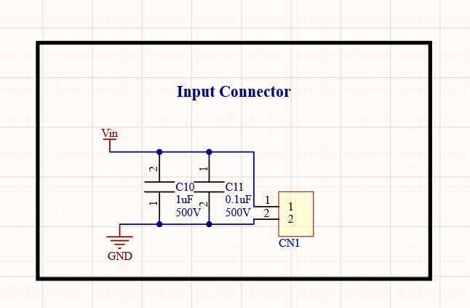

Figure 23 Input Connector and Input Bypass Capacitors

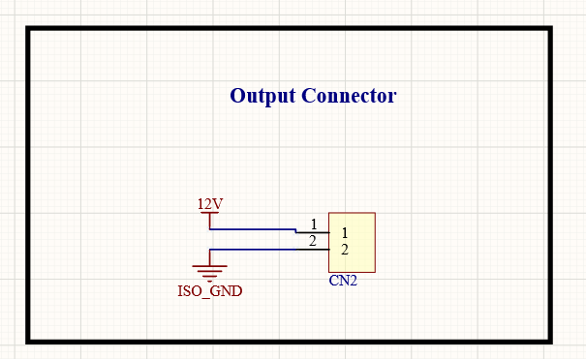

Figure 24 Output Connector

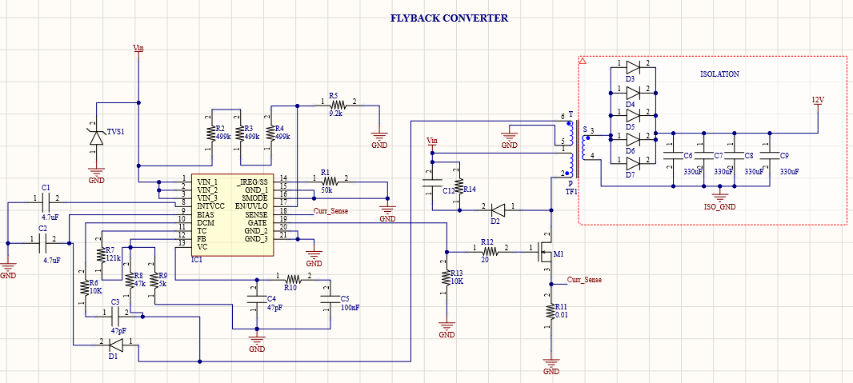

Figure 25 Flyback Converter and Controller

1. **Cost Analysis**

In Simulation Report, the total component cost was nearly $10.78 for one board, and with consumables we were expecting the total cost as $12. After simulation report, by changing some components we have decreased the component cost into $9.78. However, when we make our transformer calculations with Litz wire, and when we added PCB cost, the total cost for one board is nearly $13.88, and which is a quite fair price for that kind of design. Cost details can be seen in Table-1.

|  |  |  |  |
| --- | --- | --- | --- |
| **Manufacturer Part Number** | **Description** | **Unit Price ($)** | **Extended Price ($)** |
| CL31B475KOHNNNE | CAP CER 4.7UF 16V X7R 1206 | 0.05220 | 104,39 |
| 0603N470J101CT | CAP CER 47PF 100V C0G/NP0 0603 | 0.01281 | 25,62 |
| A750KK337M1CAAE014 | CAP ALUM POLY 330UF 20% 16V T/H | 0.18676 | 747,04 |
| 885012206046 | CAP CER 0.1UF 16V X7R 0603 | 0.02400 | 24 |
| C1210C104KCRACTU | CAP CER 0.1UF 500V X7R 1210 | 0.12644 | 126,44 |
| CGA9P4X7T2W105K250KA | CAP CER 1UF 450V X7T 2220 | 1.39040 | 1390,4 |
| C1206C104K2REC7800 | CAP CER 1206 0.1UF 200V X7R | 0.06401 | 64,01 |
| 282858-2 | TERM BLK 2P SIDE ENTRY 10MM PCB | 0.62589 | 625,89 |
| 691103110002 | TERM BLK 2POS SIDE ENT 3.5MM PCB | 0.53800 | 538 |
| ES1CHE3_A/H | DIODE GEN PURP 150V 1A DO214AC | 0.17160 | 171,6 |
| S1J-E3/61T | DIODE GEN PURP 600V 1A DO214AC | 0.09694 | 96,94 |
| CDBB3150-HF | DIODE SCHOTTKY 150V 3A DO214AA | 0.16470 | 494,11 |
| CDBB3150-HF | DIODE SCHOTTKY 150V 3A DO214AA | 0.18064 | 361,28 |
| LT8316EFE#PBF | 600VIN MICROPOWER, ISOLATED NO-O | 3.10500 | 3105 |
| IPD50R500CEAUMA1 | MOSFET N-CH 550V 7.6A TO252 | 0.40554 | 405,54 |
| RT1206BRD0750KL | RES SMD 50K OHM 0.1% 1/4W 1206 | 0.11034 | 110,34 |
| RC1206FR-07499KL | RES SMD 499K OHM 1% 1/4W 1206 | 0.01174 | 35,23 |
| ESR03EZPJ912 | RES SMD 9.1K OHM 5% 1/4W 0603 | 0.01392 | 13,92 |
| SFR03EZPJ103 | RES 10 KOHM 5% 1/10W 0603 | 0.01493 | 29,86 |
| CRCW0603121KFKEAC | RES 121K OHM 1% 1/10W 0603 | 0.00652 | 6,52 |
| CRCW060347K0FKEAC | RES 47K OHM 1% 1/10W 0603 | 0.00652 | 6,52 |
| CRCW08055K00JNTA | RES SMD 5K OHM 5% 1/8W 0805 | 0.02049 | 20,49 |
| ERJ-3EKF1502V | RES SMD 15K OHM 1% 1/10W 0603 | 0.00677 | 6,77 |
| CFG0612-FX-R010ELF | RES 0.01 OHM 1% 1W 1206 | 0.06400 | 64 |
| RNCP0603FTD20R0 | RES 20 OHM 1% 1/8W 0603 | 0.01060 | 10,6 |
| RMCF0603FT5K60 | RES 5.6K OHM 1% 1/10W 0603 | 0.00305 | 3,05 |
| PC47EI25-Z | EI CORE SMPS TRANSFORMER 1 SET | 1.02213 | 1022,13 |
| SMBJE400CA | TVS DIODE 400VWM 648VC SMB | 0.17017 | 170,17 |
| **Total Component Cost** | | | 9779,86 |
| **PCB Price** | | | 197 |
| Litz Wire | 1500 Strands-AWG38 (733000 needed) | 7.99 | 3907,11 |
| **Total Price** | | | **13883,97** |

**Table-1:** Cost Analysis

1. **PCB Design**
2. **Rules and Validations**

After concluding our Simulation Report and feedback session, we have made some changes on components, performed power and thermal analysis and started to design our PCB. While designing our PCB, our main idea was to have compact, reliable and cheap product. Among all these properties, safety was the leading property.

While designing this project, we have used Altium Designer 20, and our design is two layered and both layers include components. Before starting to drawing, we have determined to design rules which can be seen in Figure-1. Moreover, according to IPC2221A between 300V-500V the clearance between two points should be 2.5mm for safe design. However, if the PCB has conformal coating this clearance can be decreased down to 0.8mm, so we have designed our PCB in this manner. This 0.8mm clearance is validated from Saturn PCB Toolkit and can be seen in Figure-2.

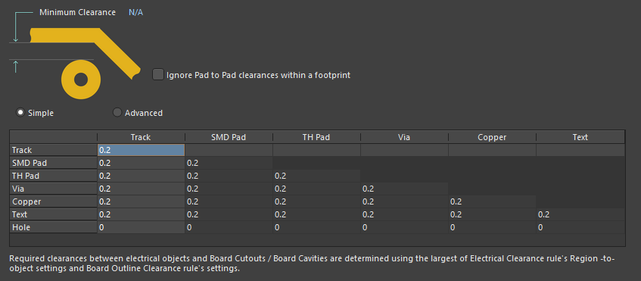

**Figure-1:** Design Rules from AD20

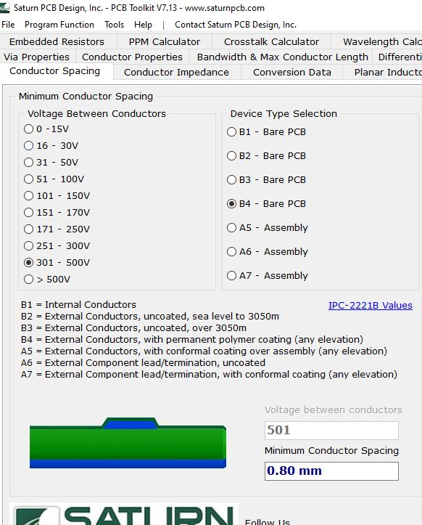

**Figure-2:** Conformal Coating Clearance Validation

From Detailed Simulations, we know that the input current is goes up to 5A. In this manner, we need to validate the line width and via properties for worst case, which is 5A. In input side, the minimum width for current carrying path is 1.3mm, and from Figure-3 we can see that this line accepts up to 6.5A current. Which means that we are on safe zone for line width.

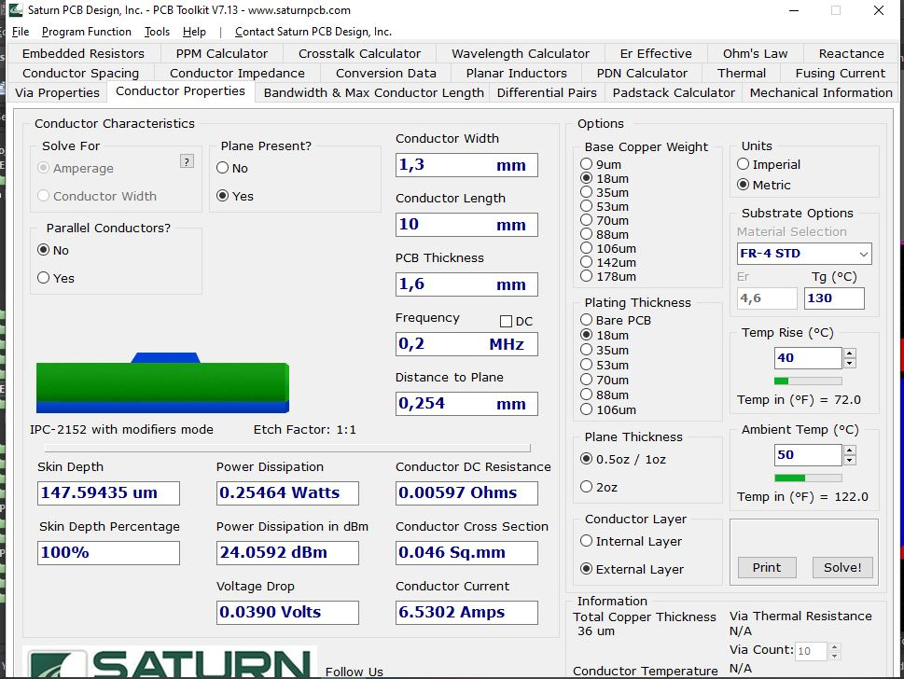

**Figure-3:** Line Width Validation

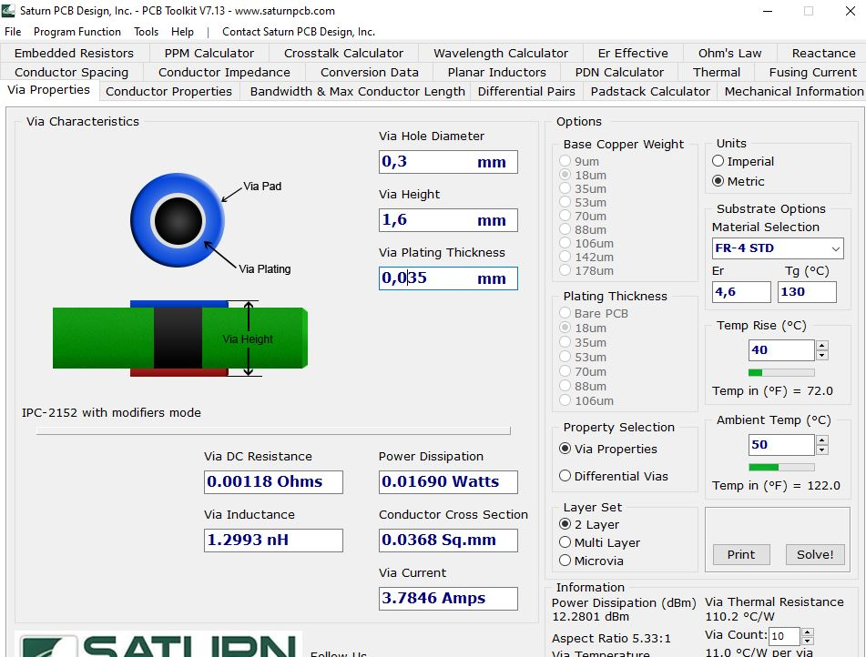

**Figure-4:** Via Validation

Lastly, when we look design rule validation of our design, which can be seen in Figure-5, we do not see any errors, which means all of the components, lines and vias are placed with respect to rules, and we have a safe design.

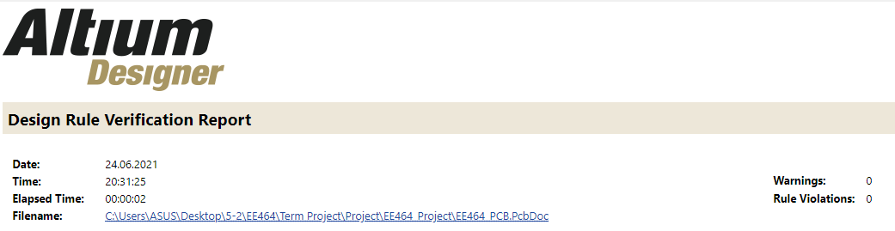

**Figure-5:** Design Rule Check

1. **2D Design**

In order to have a high power density design, we have placed the components into both layers. When we look from top view, the left hand side is high voltage side and the right hand side is the isolated (low voltage) side. The overall view of the PCB design can be seen in Figure-6.

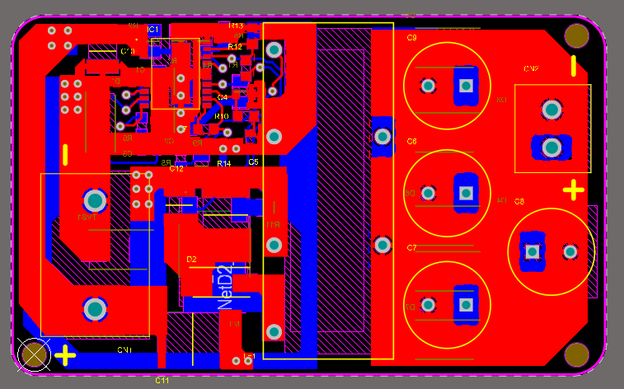

**Figure-6:** Overall View of PCB

To understand our design, we need to invastigate component placements and plane placements. Firstly, we will investigate component placements. In Figure-7 we can see the top layer and in Figure-8 we can see bottom layer component placements.

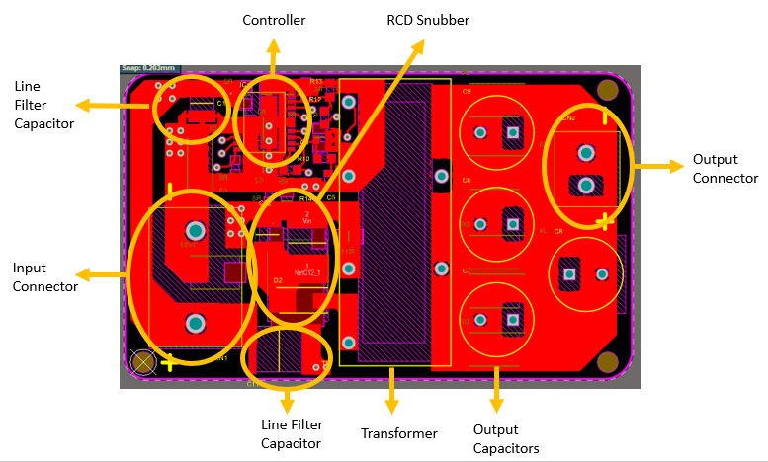

**Figure-7:** Top Layer Component Placement

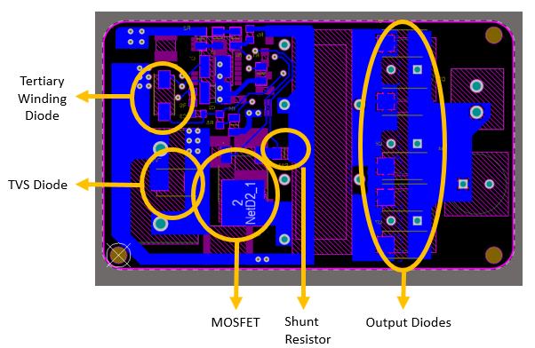

**Figure-8:** Bottom Layer Component Placement

After investigating critical component placements, we need to look plane placements for top and bottom layers to understand the whole PCB. In Figure-9 and Figure-10 we can investigate plane placements for top and bottom layers, respectively.

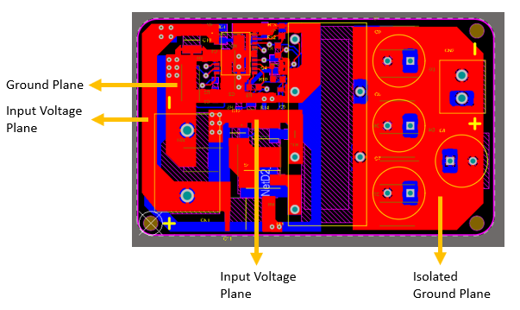

**Figure-9:** Top Layer Plane Placement

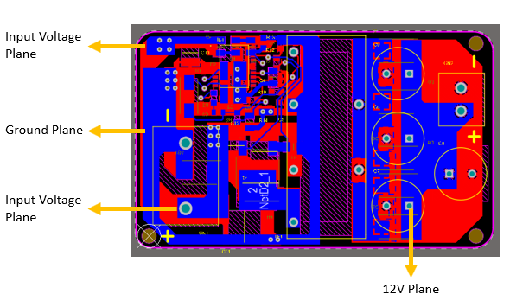

**Figure-10:** Bottom Layer Plane Placement

Lastly, when we look the mechanical properties of the board, it has dimensions of **54.6mm x 33mm**, which is a quite small board compared with its properties. The board dimensions can be seen in Figure-11. Moreover, when we look this figure, we will see the **fiducials** that are placed into board to ease manufacturing, and **positive/negative terminal indicators** of connectors for safety.

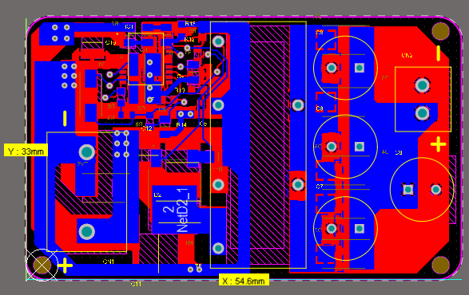

**Figure-11:** Board Dimensions and Mechanical Properties